HISTORY DEPARTMENT - ANNUAL REPORT (2022-23) 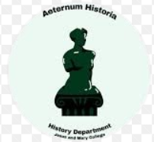
The Department of History, Jesus and Mary College is a vibrant and active body of students and teachers who have conducted several events during the academic year 2022-23, ranging from Talks, Seminars and Workshops and other events to hone the academic skills the students. The academic session of 2022-23 was headed by Dr. Richa Raj, Tic and Convenor, History Association, Dr. Sanghamitra R Verman Co-Convenor along with Ms. Ananya Rai, President, History Association and Muskan Joshi, Vice President, History Association. Other faculty members include Dr. Nilima Chitgopekar, Dr. Saumya Varghese, Dr. Richa Raj, Dr. Maya John, Dr. Tanu Parashar, Dr. Sonu Vincent, Dr. Ritesh Jaiswal, Dr. Sneha Ganguli, Dr. Rajoshree Ghosh, Ms. Eliza and Ms. Piya Malik.
The academic calendar of the History Department, Jesus and Mary College started with the election of the office bearers. Keeping the requirements of the Department and selfless dedication to the interests of the students, recruitment drive of the second and third-year students was convened to select members for the Department’s Core Team. The students selected were Srushti Sharma, Anindita Ray, Ananya Atrishya, Kimbiakmawi, Aparna Nair, Honey Babu, Alankrita Ray, Smriti Gupta, Mansha Sharma, Gunjan Madan, Neeti Aggrawal, Ramish Mushfiq, Bugi A. Sangma, Aditi Kapur, Aakarshi Srivastava, Safa Manzoor, Maria Elsa Saji, Jeseentha A. Joji, Bhavya Srivastava, Kumari Savita, Rose Mary N. Joseph and Anna Thomas.
The History Department, JMC had its first academic talk in the new session on August 10, 2022. The first talk was delivered by Dr. Zoe Woodbury High (University of Chicago) who specializes in the cultural and literary history of the early modern Deccan Sultanate and the connection between the Deccan and the broader Indian Ocean world. She gave her insights on “Hidden Histories of the Deccan: Methodology & the Study of Early Modern India”.
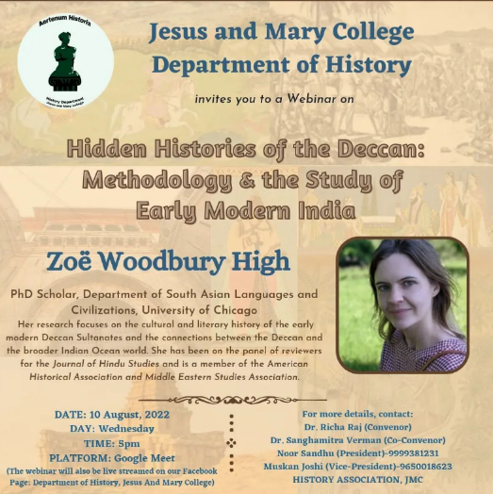

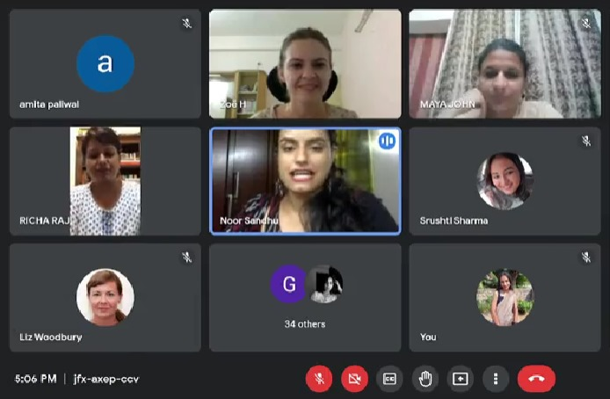
Images: Talk by Zoë Woodbury High, 10th August 2022 (Wednesday)
On September 21, 2022 we had a workshop cum interactive session in college in partnership with the ICFAI business school on the topic “The Student Development Programme on Wealth Management: Evolution and Strategies' ' delivered by Dr. Vineeta Mishra.
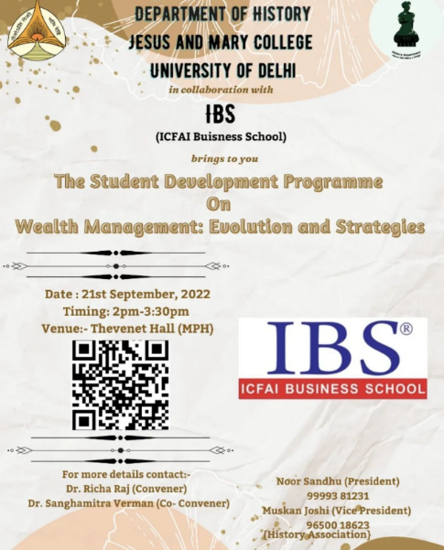
Image: Seminar by ICFAI Business School, September 21, 2022 (Wednesday)
On September 28, 2022 we also successfully conducted a ‘Research Paper Writing Workshop’ for both undergraduates and postgraduate students under the mentorship of Mr. Premanka Goswami (Associate Publisher/Penguin Random House) and Ms. Saloni Mittal (Managing Director of Ebury and Vintage/Penguin Random House).
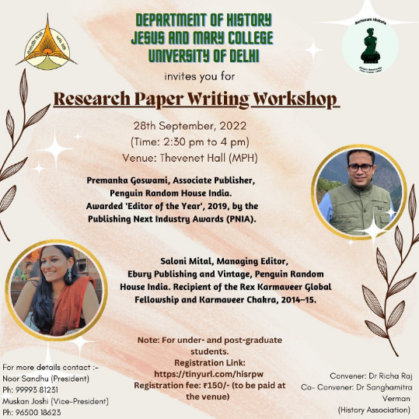
Image: Research Paper Writing Workshop by Premanka Goswami and Saloni Mital, September 28, 2022 (Wednesday)
On October 12, 2022, we organized a talk on regional histories and communities. Dr. Rahi Soren Assistant Professor, Department of Oceanographic Studies, Jadavpur University presented an interesting talk on “Endangered Santali Archives - An Indigenous Perspective”.
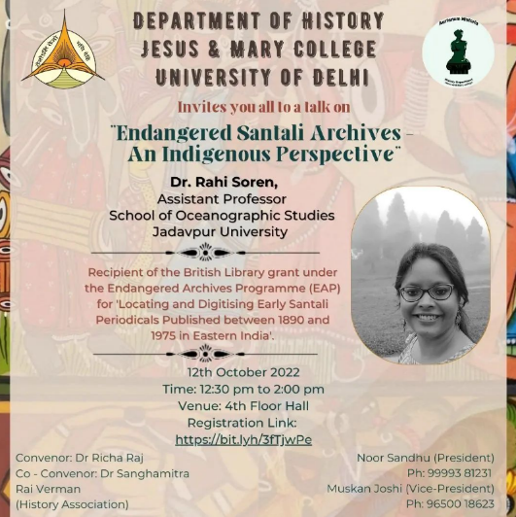
Image: Talk by Dr. Rahi Soren, October 12, 2022 (Wednesday)
On October 17, 2022 we organized an academic discussion on “Aesthetic Inequalities and Immaterial Common Goods, Experiences of the City: 12th-21st Centuries” by Prof. Arundhati Virmani (Ecole des Hautes Etudes en Sciences Sociales at Marseille) and Prof. Jean Boutier (French historian, director of studies at the École des hautes études en sciences sociales/ Marseille & member of the Centre Norbert Elia).
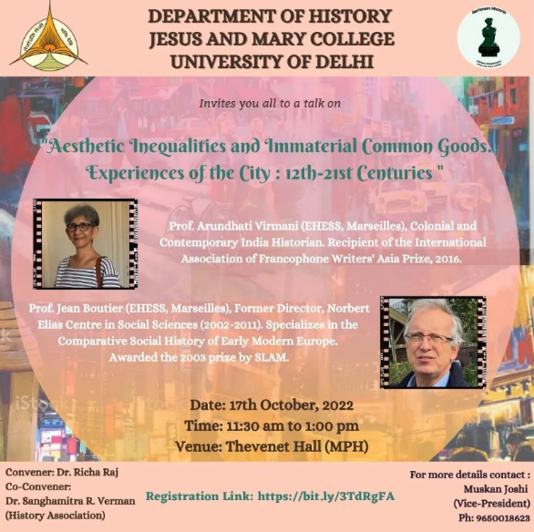
Image: Talk by Prof. Arundhati Virmani and Prof. Jean Boutier, October 17, 2022 (Monday)
Department of History also conducted a workshop cum training session on November 19, 2022. Workshop was conducted by ‘Prep Careers’. The students were briefed upon UPSC Civil Service Examination and the resource people gave detailed insights on “Beginner’s Strategy for UPSC CSE”.
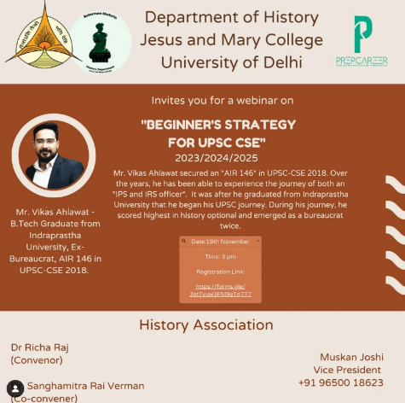
Image: Webinar by Mr. Vikas Ahlawat, November 19, 2022 (Saturday)
On February 2, 2023 Department’s Annual Fest, “Chronicle” was held. The Theme of the Fest was "Indian Cinema through a Historical Gaze". It started with an Inaugural Address and a special lecture by Dr. Karen Gabriel, Associate Professor of English, St. Stephen's College, University of Delhi. She delivered lecture was on "Presenting the Past: The Discursive Politics of Bombay Mainstream Cinema". Following this, several events were conducted simultaneously which included competitions, cultural performances as well as an open gallery related to Indian cinema.
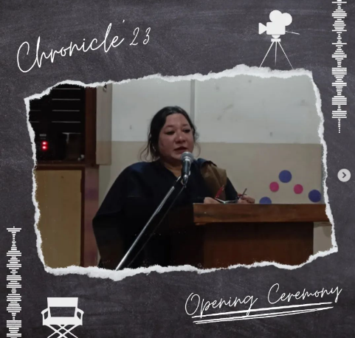
Image: Inaugural address by Dr. Karen Gabriel, 2nd February 2023 (Thursday)
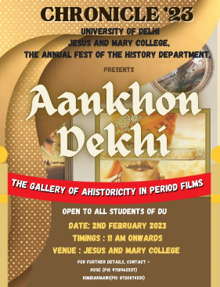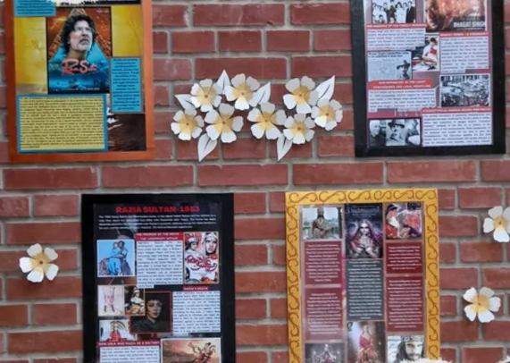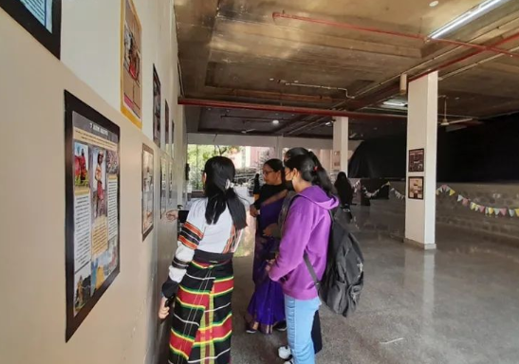
Image: Aankhon Dekhi
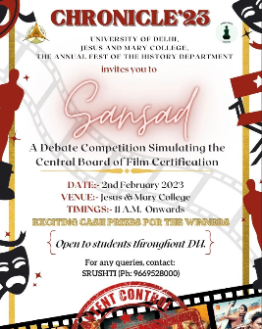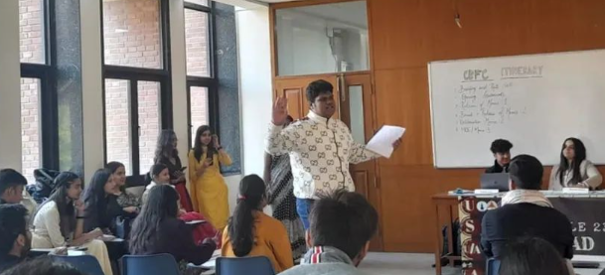
Image: Sansad: The Mock Parliamentary Debate Competition
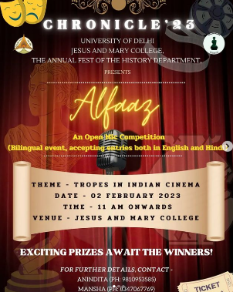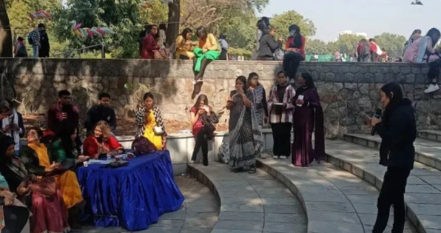
Image: Alfaaz: Bilingual Poetry Competition on the theme “Tropes in Indian Cinema”
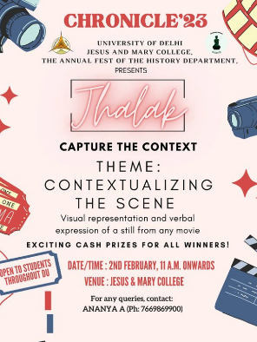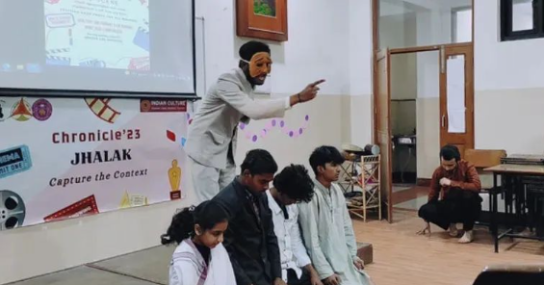
Image: Jhalak: Capture the Context Competition
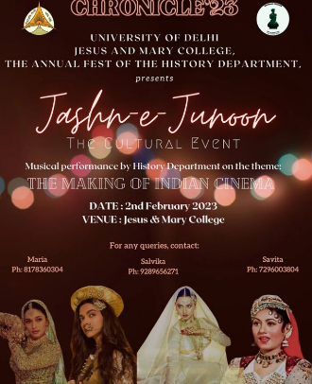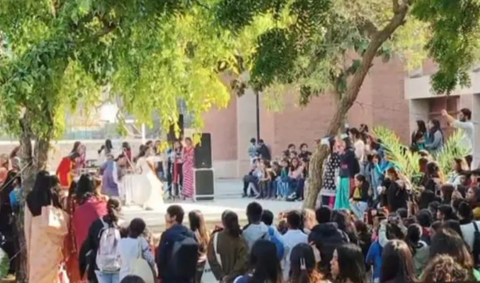
Image: Jashn-i-Junoor: Line-up of Cultural Performances, Chronicle, 2023

Two more talks were also conducted on February 8, 2023 and March 25, 2023, respectively. Prof. Andre Wink, Professor emeritus of History, University of Wisconsin, Madison delivered lecture on the topic “The making of the Indo-Islamic World: Geographical & Environmental Perspectives” on February 8, 2023. The talk was attended by large of students across various universities.
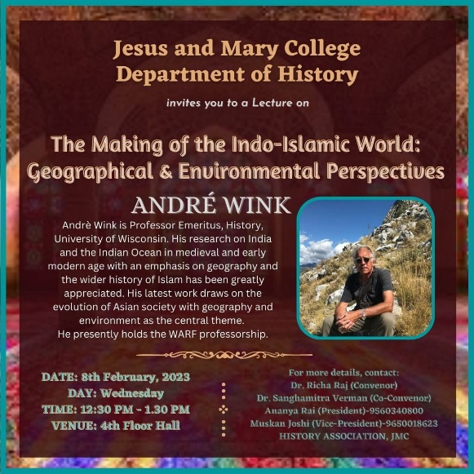
A webinar by conducted on March 25, 2023 by the department on “The Aeroplane and the making of modern India” by Dr. Aashique Ahmed Iqbal, Assistant Professor of History, Krea University.
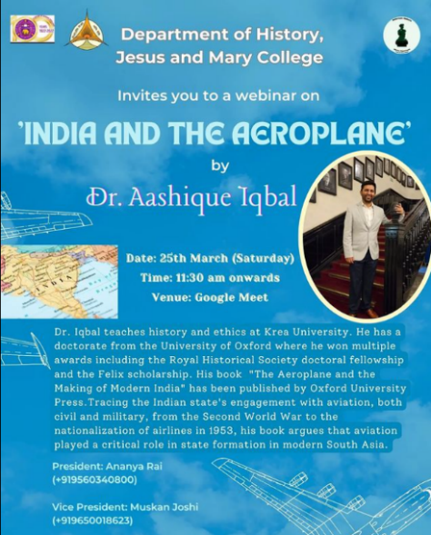
Image: Talk by Dr. Aashique Iqbal, March 25, 2023 (Saturday)
Department of History released Maazinama Volume II, the Annual academic journal of the Department of History along with Paper Presentation Competition on March 31, 2023. The theme for Maazinama Vol II was, “Do Ideas Shape the Course of History: Intellectual History and Its impact on Culture, Society and Politics". The judges for this event were Dr. Justin Mathew, Associate Professor of History, Hansraj College and Dr. Sabina Kazmi, Assistant Professor of History, St. Stephens College. The research paper presentation competition was extremely well received and showed a enthusiastic participation of students from different universities.
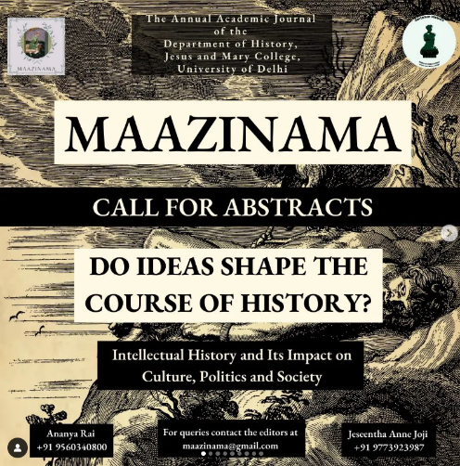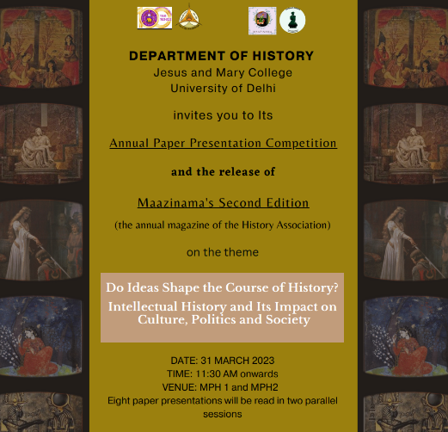
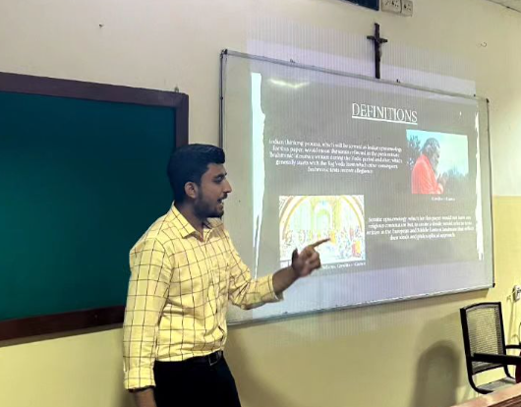
Images: Release of Maazinama Volume II as well as the Paper Presentation Competition, March 31, 2023 (Friday)

Amidst these academic events, the Oral History Archive (OHA), an initiative of the Department of History, JMC which aims to emphasise on oral accounts as valid historical sources was officially launched in 2022 started with its student recruitment process. After a rigorous screening session by the teachers of the department the student office bearers for OHA were appointed. Ms. Srushti Sharma (3rd Year, B.A. History Honours) and Ms. Aparna Nair (2nd Year, B.A. History Honours) were elected as ‘Student Coordinator’ and ‘Student Co-coordinator’, respectively. The OHA in order to effectively streamline the work further regrouped student volunteers into four teams headed by a faculty member. The four teams and faculty coordinators are as follows:
- Team on Histories of Institutions coordinated by Dr. Saumya Varghese and Dr. Tanu Parashar;
- Team on Life-Stories of Public Intellectuals in India coordinated by Dr. Maya John;
- Team on People’s History of Heritage in India coordinated by Dr. Amita Paliwal and Dr. Richa Raj;
- Team on Histories of Sexualities coordinated by Dr. Richa Raj
OHA as part of its agenda this year was able to successfully conduct interviews. Under the Team Histories of Institutions the students did research work and technical arrangements to record and transcribe the lived memory of Mr. Mithilesh Jha – the Bhelpuri vendor who has been associated with JMC for more than twenty years whose interview was conducted by Dr. Saumya Varghese.
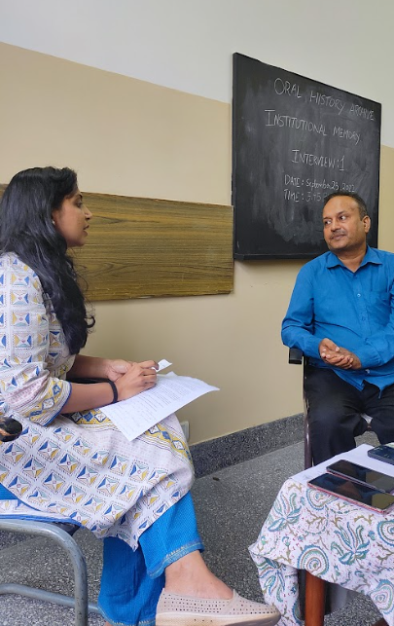
Image: Interview of Mr. Mithilesh Jha, September 23, 2022 (Wednesday)
Team Histories of Sexualities conducted an interesting workshop on “Understanding Sexualities” by Dr. Sandhya Devesan Nambiar on December 7, 2022.
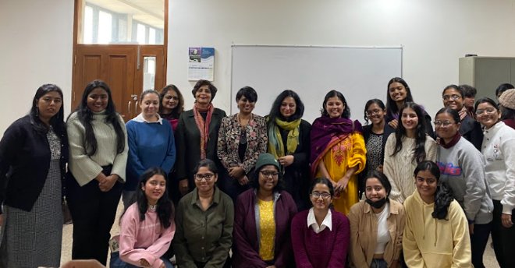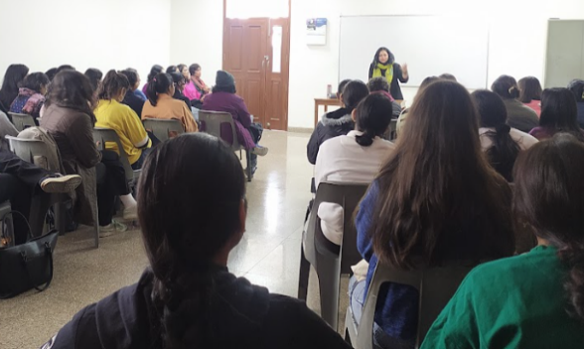
Image: Workshop by Dr. Sandhya Devesan Nambiar, December 7, 2022 (Wednesday)
Team Life-Stories of Public Intellectuals in India interviewed and transcribed the interviews conducted by Dr. Maya John and by Dr. Amita Paliwal of Ms. Binalakshmi Nepram (social activist) and Prof. Andre Wink (historian), respectively.
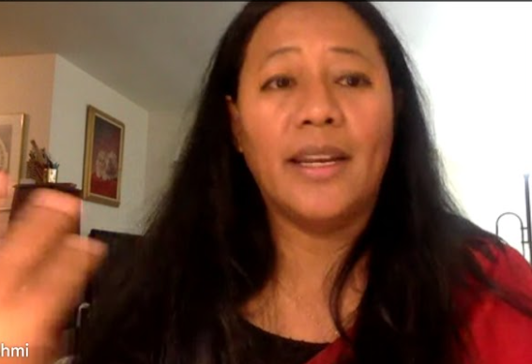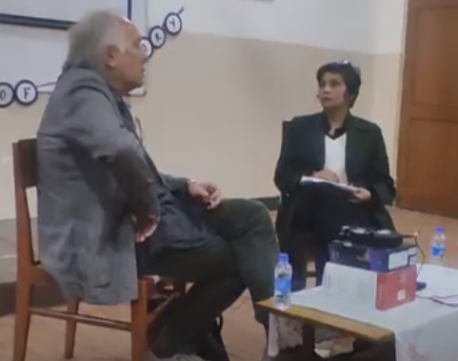
Images: Interviews of Ms. Binalakshmi Nepram, November 17, 2022 (Thursday), and Prof. Andre Wink, February 8, 2023 (Wednesday)
The team People’s History of Heritage in India conducted the interview of Prof. Daljit Kaur (Professor, Delhi University) who is closely associated with the study of Sikh history. For each interview the research, archiving (digitally) and transcribing work has been done by the student members.
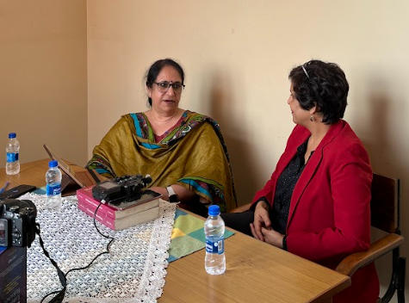
Image: Interview of Prof. Daljit Kaur, November 7, 2022 (Monday)
The Oral History Archive also collaborated with Ethnic Eight, the North East Society of JMC to present a talk on “Political Life of Memory: Birsa Munda and his Life” by Dr. Rahul Ranjan (Postdoctoral Research Fellow/OsloMet University,Oslo /Norway) on 20th February 2023.
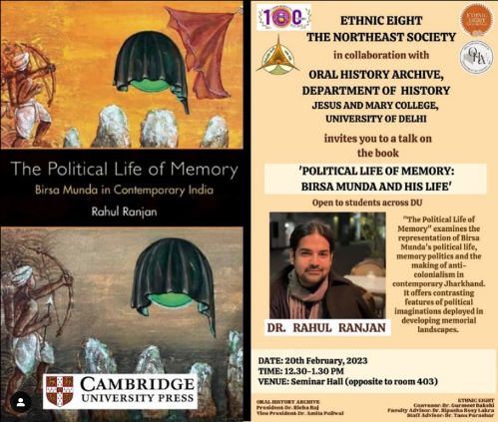
Image: Talk by Dr. Rahul Ranjan, February 20, 2023 (Monday)
Besides various organizing various academic activities including Talks, Seminars, Research Paper writing competition, department also undertook various Students Outreach Programme which included educational visits and student workshops. Students were taken to INTACH, Lodhi Road, New Delhi for attending Volunteer Training Workshop on January 20, 2023. In this workshop they were given hands on experience on various ways by which heritage (both tangible and intangible) could be preserved by college students and what role INTACH could play in such acts. The training program comprised of several lectures, heritage walks, a lab tour, a question-answer round, and interactive sessions.
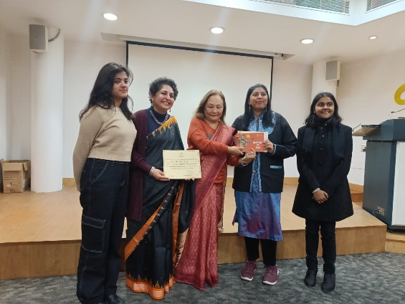
Image: Volunteer Training Workshop, INTACH, January 20, 2023

Students of History Hons. semester II was taken to International Museum Expo held at Pragati Maidan, New Delhi on May 18, 2023 to experience various activities of national and regional museums of our country, methods of museum conservation, new technologies used in archaeological explorations, etc.
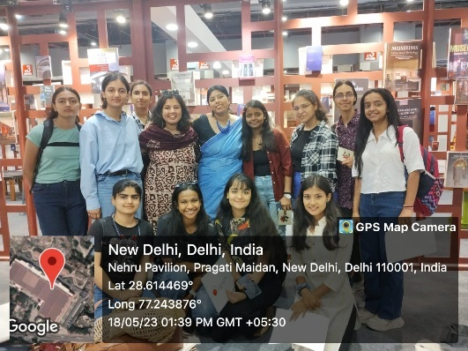
Image: International Museum Expo held at Pragati Maidan, New Delhi on May 18, 2023

On June 16, 2023 History Hons. Semester II students were taken to Rashtrapati Bhawan Museum as an endeavour for educational visit to museums and archives and thus to appraise them about importance of documentation in History.
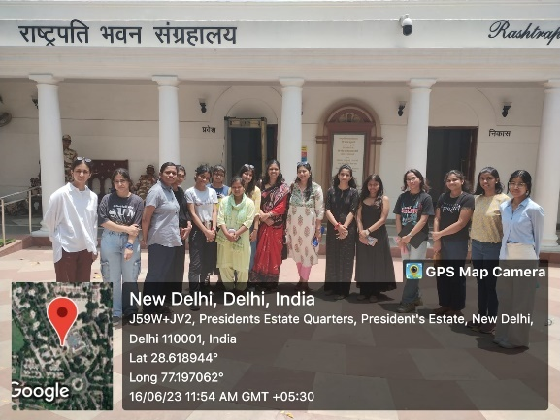
Image: Rashtrapati Bhawan Museum visit on June 16, 2023.
Under Department Outreach Programme, History department organised a faculty-student (including ex-students) fun filled get together at Lodhi Garden on April 30, 2023.
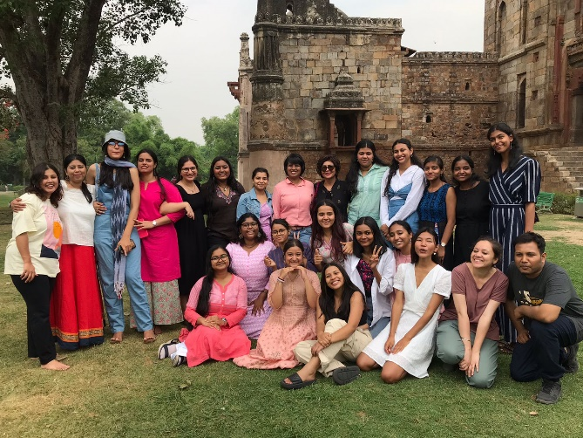
Image: Lodhi Garden Visit, April 30, 2023

